Exercise 1
Write out a reference for the following book, in the format given on the slide - list the Author, title, publisher, place of publication, year of publication.

ALL ABOUT

COFFEE
By
WILLIAM H. UKERS, M.A.
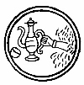
NEW YORK
THE TEA AND COFFEE TRADE JOURNAL COMPANY
1922
Reference:
Ukers W.H, 1922 All about coffee , New York, the tea and coffee trade journal company

Exercise 2 - Quiz
Is it plagiarism if you...
- Copy and paste a paragraph of text from a web site without enclosing it in quotation marks and referencing the source? Yes / No
2. Use the ideas of another author without providing a reference, even if you write them in your own words? Yes / No
3. Use work produced by another student as your own work? Yes / No
4. Copy a diagram or data table from a web site, providing a reference for the source underneath? Yes / No
5. Copy words from a book into your own work, but place quotation marks around them and provide a citation? Yes / No
6. Include a fact or saying in your assignment which is well-known without providing a reference? Yes / No
7. Incorporate text from another source, changing one or two words and providing a citation? Yes / No
Exercise 3
Given below is a paragraph from a published source on the left, and a piece of student writing on the right. Has this student documented appropriately? What do you think?
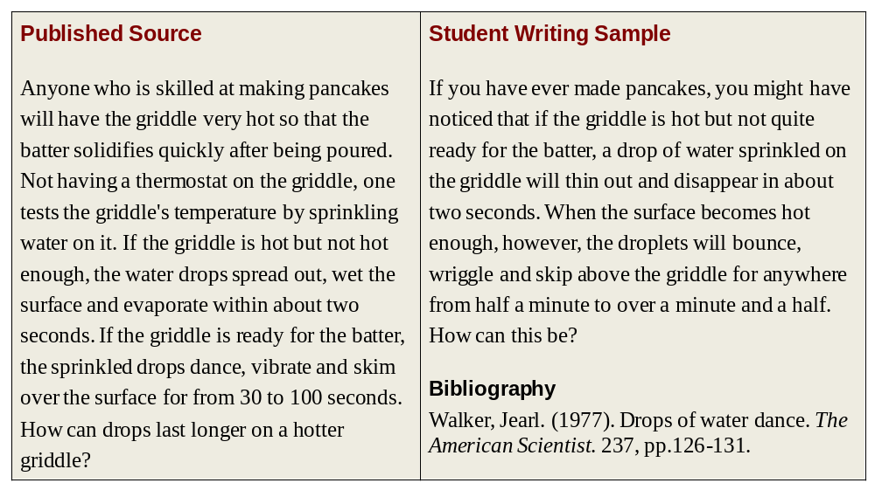
Is this student writing sample acceptable?
a) Yes! The writer of the passage has not used any of the original author's exact words.
b) Yes! The writer of the passage has credited the original source in the bibliography.
c) Both A and B.
d) No! The writer of the passage has not documented this source properly.
Exercise 4 – Online Referencing Tutorial
https://skillshub.northampton.ac.uk/2013/04/18/harvard-referencing-interactive-tutorial/

https://www.ncl.ac.uk/library/assets/external/teaching/referencing_quiz.html
If the link above does not work try this:
https://www.ncl.ac.uk/webtemplate/ask-assets/external/quiz-referencing/

